THIS WEEK’S PRAYER REQUESTS
THE CHURCH
We pray for our Diocese of Montreal, for Mary, our Bishop, Ronald Cutler, our Metropolitan-elect, and Frederick, our Primate. Within our diocese we are asked this week to pray for the Archdeaconry of Montreal, the Deanery of Western Montreal, and the priest and people of the Church of the Epiphany in Verdun. We pray also for the dioceses of the Southern Philippines (in the Philippines), Southern Virginia, Southwest Florida, Spokane and Springfield (in the U.S.A.), Southwark and Southwell & Nottingham (in England). We pray for the Pope of Rome, His Holiness Francis I. We give thanks for the religious witness in all its forms in the Church, and today we pray especially for the Society of St John the Divine in South Africa. We pray for our companions in The Territory of the People (Central BC) and in Masasi, for Jerusalem, and for the ministry in our Parish, our Incumbent, Fr Michael J. Robson.
THE WORLD
We pray for all innocent people suffering due to war, strife and intolerance, for the United Nations and peacekeepers serving throughout the world, for those who govern and hold authority in the nations of the earth, Elizabeth, our Queen, David Johnston, as he steps down as Governor General, & for Julie Payette, to be installed in that office tomorrow, Justin Trudeau, our Prime Minister, J. Michel Doyon, our Lieutenant Governor, Philippe Couillard, our Premier, Bruno Guilbault, our Mayor, and for all MPs, MNAs, and Councillors.
EACH OTHER
In our Parish Cycle of Prayer we pray this week for Zina Herbert. We pray for the well being of Marjorie Barton, Shelby-Lee Teresiuk, Shannon McGinty, Marilyn Leduc, Jake Dobbs, Kathy Frankland, Barbara Gentry, Ted Kimber, Lauren, Lydia Hubbard and Walton Denman. We pray for all refugees, captives, hostages, the war-weary, the lonely, victims of violence, elder abuse, substance abuse, natural disasters, especially at this time as a result of the recent and threatening storms in the Caribbean, the United States and Mexico, the earthquakes in Mexico and wild fires in the United States and Canada, those seeking employment, the homeless, those troubled in mind or spirit. The altar flowers are given in loving memory of Gordon Scott and Gregg Tinkler from Irene & Family. From our Book of Remembrance, we pray for the repose of the souls of Gordon John Scott, Florence Lillian Kimber (née Johnson), Florence Hildreth Scott (née Hilrich), Hubert Henri Hacala, James Malcolm Parkinson, Nancy White, Christina Rahr, and Eileen Tinkler (née Boyce), and for all those whose years’ mind falls at this time.
Prayer contact: - John Clague,
If you have a name to add or
changes to make to the prayer list:
Phone: (450) 834 3905.
Email: - jclague@sympatico.ca
Requests for Flower and/or Candle Memorials:
contact: Ann Allen Phone: (450) 834 2492
Visit our Parish Web Site at: - www.christchurchrawdon.com
 | UPCOMING EVENTS
 | Monday |  | 7pm, ACW Meeting at the home of Sue-Ellen Jones-Millar
 | Tuesday |  | ECOL – 9.30-11.00  Prescription & Over the Counter Medications – Do’s & Don’ts  Please see Notice Board for details.
 | Tuesday |  | 2pm, service at St Anne’s Residence  All are welcome.
 | Tuesday |  | 7.30pm ACW Card Party
 | Oct. 8th |  | Parish Celebration of Harvest Thanksgiving, Christ Church
 | Oct. 14th |  | 2pm, Meeting Jesus at the Border  Eucharist at Havelock Fairgrounds with Bps Mary & Bruce, Sr Mary Jo Leddy
 | Oct. 15th |  | Fr Claude Bedard will be with us to talk about the Pennies for Water project.
 | Oct. 28th |  | 6pm, Harvest Supper, Rawdon Golf Club  Tickets: $20; children, 6-12, $6
 | Nov. 26th |  | The Reign of Christ (our Feast of Title)  Preacher: The Ven. Robert Camara, new Vicar-General of our diocese
 | Dec. 17th |  | Lessons & Carols at Masonville
 | Feb. 2018 |  | Winter BBQ. Theme: Mexican Fiesta
CALENDAR FOR THE WEEK AHEAD
Monday |  | Feria.
Tuesday |  | Feria.
Wednesday |  | Francis of Assisi, Friar.
Thursday |  | Feria.
Friday |  | Feria.
Saturday |  | Feria.
Sunday |  | Harvest Thanksgiving.

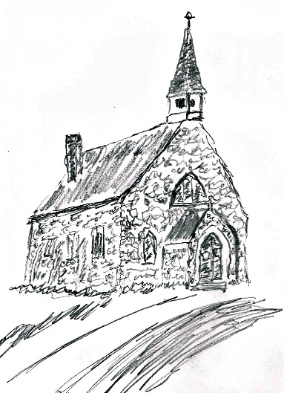

Christ Church, Rawdon
17th Sunday after Pentecost (Proper 26)
October 1, 2017
Some material printed here is copyright © 2004 by the General Synod of the Anglican Church of Canada. All rights reserved. Reproduced under license from ABC Publishing, Anglican Book Centre, a ministry of the General Synod of the Anglican Church of Canada, from Anglican Liturgical Library. Further copying is prohibited.
9.20am Morning Prayer BAS p.47
Psalms 66 & 67 p.786. Acts 9:36-43.
10.00am Sung Eucharist BAS p.185
Processional Hymn: 318 (Stand)
Rejoice Today with One Accord
The Gathering of the Community
Priest: The grace of our Lord…be with you all.
People: And also with you.
Almighty God, to you all hearts are open, all desires known, and from you no secrets are hidden. Cleanse the thoughts of our hearts by the inspiration of your Holy Spirit, that we may perfectly love you, and worthily magnify your holy name; through Christ our Lord. Amen.
Summary of the Law
Our Lord Jesus Christ said, “The first commandment is this: ‘Hear, O Israel, the Lord our God is the only Lord. You shall love the Lord your God with all your heart, with all your soul, with all your mind, and with all your strength.’ The second commandment is this: ‘Love your neighbour as yourself.’ There is no other commandment greater than these. On these two commandments hang all the law and the prophets.”
Lord have mercy upon us, and write these your laws in our hearts, we pray.
Lord, have mercy upon us.
Christ, have mercy upon us.
Lord, have mercy upon us.
The Collect: (Remain Standing)
God of our salvation, we falter before the demands of your word and turn away from your call to life. As you showed mercy to your people of old, pour out your mercy on us, so that we may turn from our sinfulness and walk the path of self-emptying love made known in Jesus Christ, who lives and reigns with you and the Holy Spirit, one God, now and forever. Amen
The Proclamation of the Word (Sit)
The First Reading: Exodus 17:1–7
From the wilderness of Sin the whole congregation of the Israelites journeyed by stages, as the Lord commanded. They camped at Rephidim, but there was no water for the people to drink. The people quarrelled with Moses, and said, "Give us water to drink." Moses said to them, "Why do you quarrel with me? Why do you test the Lord?" But the people thirsted there for water; and the people complained against Moses and said, "Why did you bring us out of Egypt, to kill us and our children and livestock with thirst?" So Moses cried out to the Lord, "What shall I do with this people? They are almost ready to stone me." The Lord said to Moses, "Go on ahead of the people, and take some of the elders of Israel with you; take in your hand the staff with which you struck the Nile, and go. I will be standing there in front of you on the rock at Horeb. Strike the rock, and water will come out of it, so that the people may drink." Moses did so, in the sight of the elders of Israel. He called the place Massah and Meribah, because the Israelites quarrelled and tested the Lord, saying, "Is the Lord among us or not?"
Psalm 78:1–4, 12–16
Refrain: The Lord split the rocks and gave them drink.
Hear my teaching, O my people; incline your ears to the words of my mouth. I will open my mouth in a parable; I will declare the mysteries of ancient times. R
Refrain: The Lord split the rocks and gave them drink.
That which we have heard and known, and what our forefathers have told us, we will not hide from their children. We will recount to generations to come the praiseworthy deeds and the power of the Lord, and the wonderful works he has done. R
He worked marvels in the sight of their forefathers, in the land of Egypt, in the field of Zoan. He split open the sea and let them pass through; he made the waters stand up like walls. R
He led them with a cloud by day, and all the night through with a glow of fire. He split the hard rocks in the wilderness and gave them drink as from the great deep. He brought streams out of the cliff, and the waters gushed out like rivers. R
The Second Reading: Philippians 2:1–13
If then there is any encouragement in Christ, any consolation from love, any sharing in the Spirit, any compassion and sympathy, make my joy complete: be of the same mind, having the same love, being in full accord and of one mind. Do nothing from selfish ambition or conceit, but in humility regard others as better than yourselves. Let each of you look not to your own interests, but to the interests of others. Let the same mind be in you that was in Christ Jesus, who, though he was in the form of God, did not regard equality with God as something to be exploited, but emptied himself, taking the form of a slave, being born in human likeness. And being found in human form, he humbled himself and became obedient to the point of death—even death on a cross. Therefore God also highly exalted him and gave him the name that is above every name, so that at the name of Jesus every knee should bend, in heaven and on earth and under the earth, and every tongue should confess that Jesus Christ is Lord, to the glory of God the Father. Therefore, my beloved, just as you have always obeyed me, not only in my presence, but much more now in my absence, work out your own salvation with fear and trembling; for it is God who is at work in you, enabling you both to will and to work for his good pleasure.
Gospel Acclamation:
Alleluia, alleluia, alleluia.
Alleluia, alleluia, alleluia.
My sheep hear my voice, says the Lord; I know them and they follow me.
Alleluia, alleluia, alleluia.
The Lord be with you.
And also with you.
The Holy Gospel Matthew 21:23–32
Glory to you, Lord Jesus Christ.
When Jesus entered the temple, the chief priests and the elders of the people came to him as he was teaching, and said, “By what authority are you doing these things, and who gave you this authority?” Jesus said to them, “I will also ask you one question; if you tell me the answer, then I will also tell you by what authority I do these things. Did the baptism of John come from heaven, or was it of human origin?” And they argued with one another, “If we say, ‘From heaven,’ he will say to us, ‘Why then did you not believe him?’ But if we say, ‘Of human origin,’ we are afraid of the crowd; for all regard John as a prophet.” So they answered Jesus, “We do not know.” And he said to them, “Neither will I tell you by what authority I am doing these things. What do you think? A man had two sons; he went to the first and said, ‘Son, go and work in the vineyard today.’ He answered, ‘I will not’; but later he changed his mind and went. The father went to the second and said the same; and he answered, ‘I go, sir’; but he did not go. Which of the two did the will of his father?” They said, “The first.” Jesus said to them, “Truly I tell you, the tax collectors and the prostitutes are going into the kingdom of God ahead of you. For John came to you in the way of righteousness and you did not believe him, but the tax collectors and the prostitutes believed him; and even after you saw it, you did not change your minds and believe him.”
The Gospel of Christ.
Praise to you, Lord Jesus Christ.
Sermon: Our Incumbent (Sit)
The Apostles’ Creed (p.189) (Stand)

The Prayers of the People (Kneel or Sit)
Remembering our Lady, ...to Christ our God.
To you, O Lord.
Confession & Absolution (p.191)
The Peace (Stand)
Offertory Hymn: 375 (499)
At the Name of Jesus
After each verse repeat the first 2 lines of v. 1
Prayer over the Gifts:
Eternal God, in Jesus Christ we behold your glory. Receive the offering of your people gathered before you, and open our hearts and mouths to praise your great salvation, the same Jesus Christ our Lord. Amen
The Great Thanksgiving
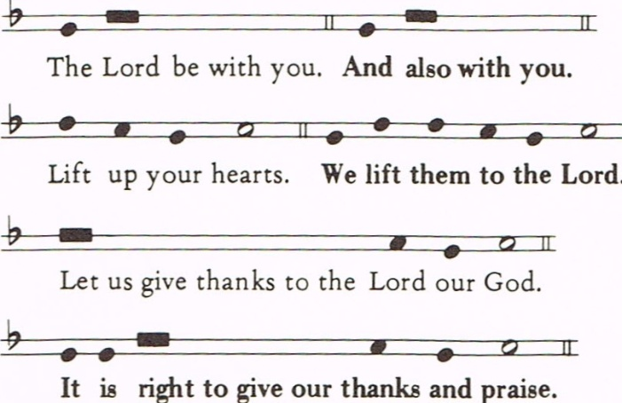

The celebrant continues with the preface

Sanctus & Benedictus (CP: 735)
the prayer continues
The Lord’s Prayer (p.211)
The Breaking of the Bread (p.212)
Agnus Dei (CP: 747)
Jesus, Lamb of God, have mercy on us.
Jesus, bearer of our sins, have mercy on us.
Jesus, redeemer, redeemer of the world,
give us your peace, give us your peace.
All baptized Christians who are communicants in their own church are welcome to receive communion. Those who do not receive communion are invited to come up for a blessing.

Communion Hymn: 386 (303)
When I Survey the Wonderous Cross
Prayer after Communion: (Stand)
Father in heaven, strengthen the unity of your Church, so that we who have been fed with holy things may fulfil your will in the world. We ask this in the name of Jesus Christ our Lord. Amen
The Blessing
Announcements (Sit)
Recessional Hymn: 387 (Stand)
All Praise to Thee
Dismissal (Remain Standing)
Let us go forth in the name of Christ.
Thanks be to God!
We welcome our visitors today.
Please come back and join us again soon.
TODAY’S DUTY ROSTER
Celebrant: Our Incumbent, the Venerable Michael J. Robson. Chalice Bearer: Marion Loffelmann. Servers: Anne Millar. Marion Gardner. Louis-Martin Riquier. Ushers: Brenda Purcell. Shari Gallagher. Presenter: Brenda Purcell Readers: Jarka Loffelmann. Barbara Ferguson. Derek Morris. Intercessor: Marion Loffelmann. Organist: Brigitte Secco.
SERVICES IN THE WEEK AHEAD
Tuesday 2pm, Service at St Anne’s
Wednesday 7pm, Midweek Eucharist
Sunday 9.20am, Morning Prayer
10am, Holy Eucharist
Monthly Income Report 2017
Monthly revenue required to keep doors open: $10,850
 |  | Revenue | Surplus |  | Shortfall
May |  | 12,978 | 2,128 | -
June |  | 9,915 | - | 935
July |  | 10,085 | - | 765
Shortfall, year-to-date: $9,094
Canadian Church Wall Calendars for 2018 are now available from Barbara Ferguson at $7 each. (They make excellent Christmas gifts.)

